# HMS Sign up

## Description:

Users easily Sign up to the system by giving practice information and personal information to connect with the HMS to provide you with the best facilities. And to sign in to the system it can smartly identify the user and show their constraints and set their permitted areas.

## User Story:

1. New Users will be able to sign up for the application by giving practice information and personal information.
2. Submit the following information to sign up successfully.
   1. Practice Information.
3. Practice name
4. Practice address
5. Practice address 2
6. City
7. Select state
8. City
9. Select State
10. Zip Code
    1. User Information.
11. Select Designation
12. First Name
13. Middle initial
14. Last name
15. User name
16. Email address
17. Phone number
18. Password
19. Confirm password
20. reCAPTCHA
21. Terms and Conditions.
22. Submit Form
23. Validation message summary
24. Maintain user sign-up summary for sign-up credentials.
25. And sign in after submitting the signup form.

## Business Rules:

1. On the signup page set placeholder messages and button text according to the selected culture.
2. For Practice registration in HMS first entered all the practice information and user information.
3. The action button (Submit) is placed at the bottom of the page.
4. On sign-up failed user will show the validation message. And all the information in the signup form is mandatory to fill up.
5. On sign-up success, user email sends to system admin for approval.
6. The system will create a user Sign up history, to match user email and password in the login page for login to the system.

## Tool Tip:

1. Practice Information.
2. Practice name
3. Practice address
4. Practice address 2
5. City
6. Select state
7. City
8. Select State
9. Zip Code
10. User Information.
11. Select Designation
12. First Name
13. Middle initial
14. Last name
15. User name
16. Email address
17. Phone number
18. Password
19. Confirm password
20. reCAPTCHA
21. Terms and Conditions.
22. Submit Form

## Database and SP’s:

Table:

Stored Procedure:

## ER- Diagram:

## Screenshot:

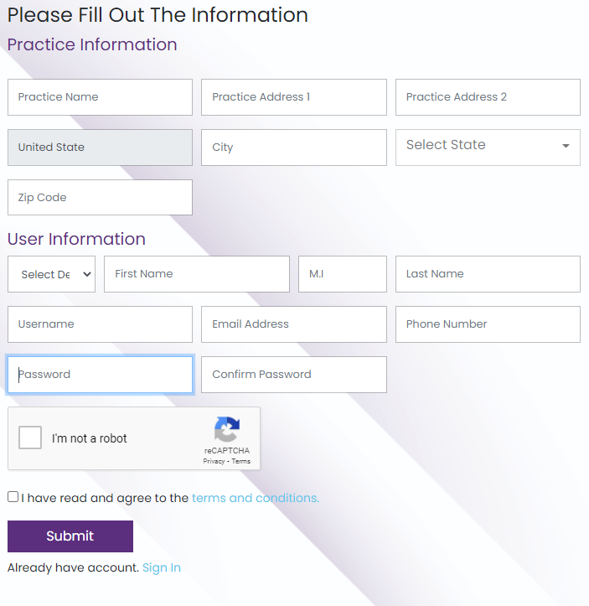

# HMS Login

## Description:

HMS login is user-friendly we don’t need to give extra information about user roles. It can smartly identify the user and show their constraints and set their permitted areas.

## User Story:

1. Users will be able to log in to the application according to the user group
2. Users want to reset the password in case of user failed to remember the old password
3. Validation message summary
4. Maintain user login summary

## Business Rules:

1. On the login page set placeholder messages and button text according to the selected culture.
2. Get user’s data from the user table according to the email address.
3. Match the encrypted password.
4. On invalid password check for user attempt with user authentication with max attempt.
5. On invalid passwords also add user login attempts on the user table.
6. On login success, the system will collect and show only permission areas based on the group.
7. On login system will check for URL, if given then redirect to the URL otherwise redirect to the dashboard.
8. The system will create a user login history.

## Tool Tip:

1. Enter username.
2. Enter password.

## Database and SP’s:

1. Table:
2. Stored procedure:

## ER- Diagram:

## Screenshot:

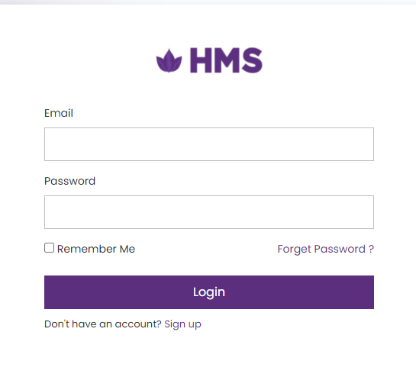

# HMS Recover Password

## Description:

HMS login is user-friendly we don’t need to give extra information about user roles. It can smartly identify the user and show their constraints and set their permitted areas. If the user doesn’t remember his/ her password, then there is an option to recover the password.

## User Story:

1. As a User, I will be able to recover their password if the user failed to remember the old password.
2. Users will easily recover Passwords by clicking on forget Password option in the login form.
3. A new page of forgetting passwords is open. And user requests a password reset by giving an Email Address in the form.
4. Also, select the checkbox and tell the system that I am not a robot.
5. Two buttons are placed at the bottom of the form
   * + - 1. Cancel
         2. Submit

## Business Rules:

1. User requests for password reset by giving an Email Address in the form.
2. Must check the reCAPTCHA and click on submit button.
3. The request is transferred to the user’s email.
4. User click on request and popup form is open and change the password by giving password field and Confirm Password field.
5. Information about reset passwords is stored in the database.
6. Click on the Cancel button and redirect to the Login Page.

## Tool Tip:

1. Enter Email.
2. Select reCAPTCHA.

## Database and SP’s:

1. Table:
2. Stored procedure:

## ER- Diagram:

## Screenshot:



# HMS Change Password

## Description:

Password provides the defense against unauthorized access to your computer and personal information. Must change your password in order to ensure the security of your system. If you do not change on regular basis, your familiarity with your password would eventually lead to its compromises.

## User Story:

1. As a User, I will be able to change the password for defense against unauthorized access to our system and personal information.
2. Users will easily change Passwords by clicking on the setting icon option in the dashboard.
3. A popup form of forgetting passwords is open. And users enters all the information are required in the form.
4. The save button is placed at the bottom of the form.
5. Users also enable two-factor Authentication and cancel subscriptions on the setting page.

## Business Rules:

1. Users want to change their passwords.
2. Enter current password, new password, and confirm the new password.
3. Click on the save button to save the new password.
4. The updated password is saved in the database.

## Tool Tip:

1. Enter Current Password.
2. Enter New password.
3. Enter Confirm Password.

## Database and SP’s:

1. Table:
2. Stored procedure:

## ER- Diagram:

## Screenshot:



# HMS Update User Information.

## Description:

Users easily Sign up to the system by giving practice information and personal information to connect with the HMS to provide you with the best facilities. And to sign in to the system it can smartly identify the user and show their constraints and set their permitted areas.

## User Story:

The user of the practice updates their information by clicking the on update button(…) with 3 dots placed at the top left in the Practice name, User name, and User Role block. Click on update a popup form is displayed on the screen, and easily update the information that is required and click on update.

## Business Rules:

1. As a user, I want to update.
2. The user will update successfully by giving the information that is required.
3. Click on the Save button to update successfully and update information is stored in the database and updated.
4. If the update is not successfully updated system will show the validation message.
5. All the fields in the form is mandatory.

## Tool Tip:

1. User Information.
2. First Name
3. Middle initial
4. Last name
5. User name
6. Email address
7. Phone number
8. Select City
9. State
10. Zip Code

## Database and SP’s:

Table:

Stored Procedure:

## ER- Diagram:

## Screenshot:

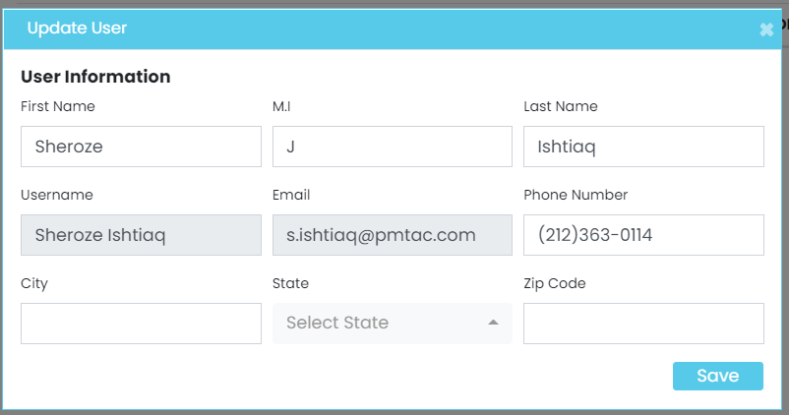

# HMS Enroll Patient

## Description:

1. The patient is an important part of HMS. The user will add patients from the patient dashboard page. 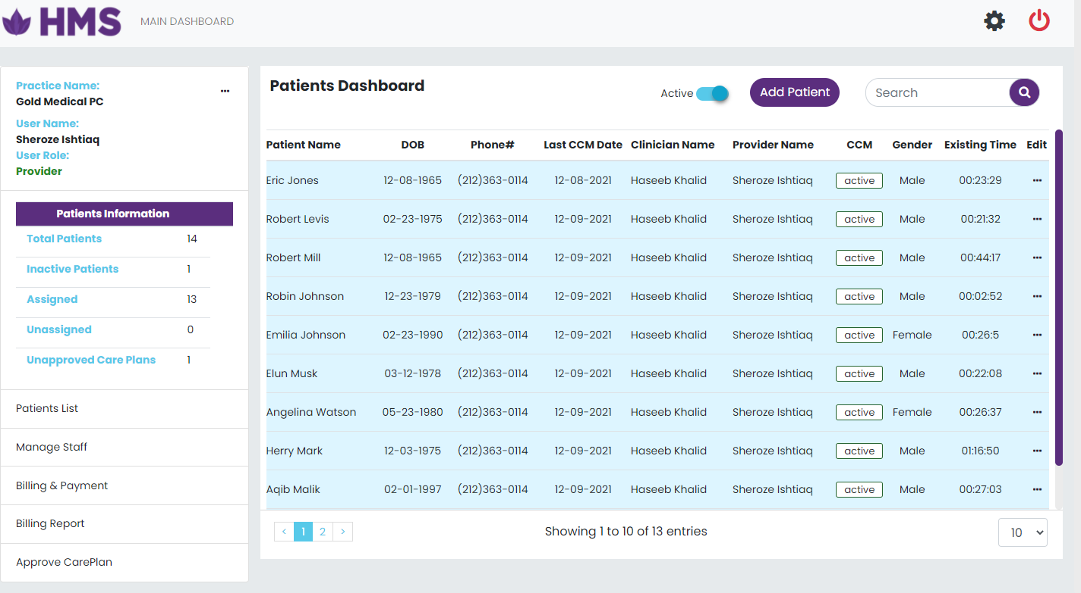
2. The user will be able to perform a crud operation.
3. The patient form view is displayed popup when clicking on add patient button placed at the top of the patient dashboard.

## User Story:

1. After login directly redirects to the Patient dashboard where all the operations are managed by the different roles shows only permission areas based on the group.
2. Information of total patients is displayed in the patient dashboard.
3. Footer of the list view of the dashboard show pagination, total entries, and the drop-down option where shows rows according to the selected number.
4. The header of the list view shows the active check button, add patient, and filter to search patient name.
5. The patient form view is displayed popup when clicking on add patient button placed at the top of the patient dashboard.
6. Click on the Active checkbox to see active and inactive patient information.
7. The search option is shown with the add patient button.
8. To active the patient, click on CCM Active action button, a popup form is open and assigns provider and clinician to inactive the user.
9. Click on Edit to update patient information.
10. Click on Edit to active and inactive patient.

## Business Rules:

1. For Enroll new patients in HMS, enter all the patient information.
2. The action button (Add) is placed at the bottom of the page.
3. The action button (CCM Enrolment) with add button shows all the validation.
4. If a patient is not added successfully, the system will show the validation message.
5. If add operation successfully then redirect to the dashboard.
6. The information of the inserted patient is shown on the unassigned page.

## Tool Tip:

Patient Demographics

1. First Name
2. Last Name
3. Date of Birth
4. Gender
5. Phone #
6. Email
7. Languages
8. Insurance
9. Ins Policy #
10. Address

## Database and SP’s:

1. Table:
2. Stored Procedure:

## ER- Diagram:

## Screenshot:

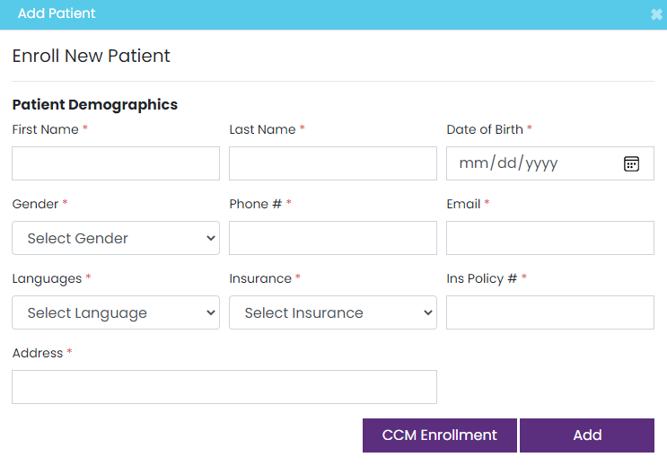

# HMS Update Patient Information

## Description:

1. The patient is an important part of HMS. The user will update patients from the patient dashboard. 
2. The user will be able to perform a crud operation.
3. The update patient form view is displayed popup when clicking on edit placed at the patient table in patient dashboard.

## User Story:

1. After login directly redirects to the Patient dashboard where all the operations are managed by the different roles shows only permission areas based on the group.
2. Information of total patients is displayed in the patient dashboard.
3. Footer of the list view of the dashboard show pagination, total entries, and the drop-down option where shows rows according to the selected number.
4. The header of the list view shows the active check button, add patient, and filter to search patient name.
5. The updated patient form view is displayed popup when clicking on edit placed at the patient table on patient dashboard.
6. Click on the Active checkbox to see active and inactive patient information.
7. The search option is shown with the add patient button.
8. To active the patient, click on CCM Active action button, a popup form is open and assigns provider and clinician to inactive the user.
9. Click on Edit to update patient information.
10. Click on Edit to active and inactive patient.

## Business Rules:

1. To update patients’ information in HMS, enter the patient information that is required to update.
2. The action button (Edit) is placed at the last column of the patient table of the page.
3. All information is gathered from the patient and click on the update button.
4. Update operation successfully then redirect to the dashboard.
5. The information of updated patient information is shown on the patient table.

## Tool Tip:

## Patient Demographics

1. First Name
2. Last Name
3. Date of Birth
4. Gender
5. Phone #
6. Email
7. Languages
8. Insurance
9. Ins Policy #
10. Address

## Database and SP’s:

1. Table:
2. Stored Procedure:

## ER- Diagram:

## Screenshot:

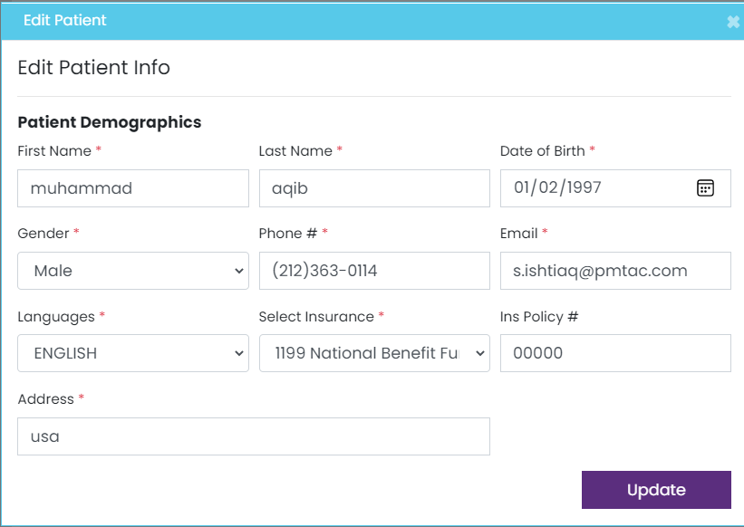

# HMS Enroll CCM

## Description:

The term chronic disease means long-term disease. Chronic diseases are not passed from person to person, there are of long duration and generally slow progression. Some of the common diseases include asthma, cancer, CCM enrollment is important for every patient because patients are added with the patient information. Without gathered information about any chronic diseases and doesn’t assign any provider and clinician.

## User Story:

As a user, I want to enroll CCM and activate CCM Service for the patient. The user gathered all information from the patient in the form that is required.

1. Chronic Condition
2. ICD
3. Patient Type
4. Best Time To Call
5. Communication Preferences
6. Select Clinician
7. Select Provider
8. Patient consent

When enrolling CCM services for patients, Patient consent is compulsory in the form to check. If the patient understands all the benefits and information about the Medicare Chronic Care Management Program.

1. The Medicare CCM Program Benefit.
2. How to revoke their participation in CCM.
3. That their health information may be shared with their other medical providers.
4. That only one practitioner can bill for CCM per month, and there may be a copy for the service.
5. If patient agree then click on save action button.

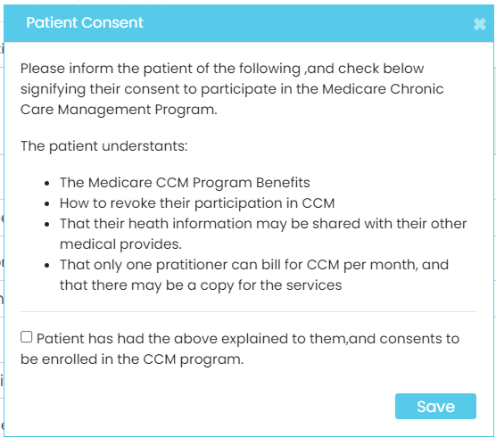

## Business Rules:

1. Users want to enroll CCM for newly added patients.
2. Click on the Save button if all the information is gotten from the user.
3. The patient CCM enrollment is complete and the patient information is removed from the unassigned page.
4. The newly added patient CCM is completed successfully the patient information is now shown on the assigned page.
5. Provider and clinician are successfully assigned to the patient and now the patient is in the active state.
6. User also active and inactive the patient CCM enrollment

## Tool Tip:

For Activate CCM Service for Patient.

1. Chronic Condition
2. ICD
3. Patient Type
4. Best Time To Call
5. Communication Preferences
6. Select Clinician
7. Select Provider
8. Patient consent

## Database and SP’s:

1. Table:
2. Stored Procedure:

## ER- Diagram:

## Screenshot:

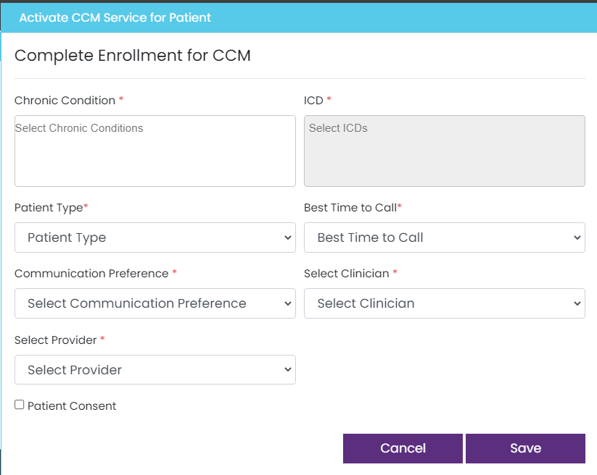

# HMS CarePlan.

## Description:

The main purpose of HMS is to provide care to the patient. A care plan is a specially crafted document for aged patients that are not able to go to hospitals. Patients are easily directly consulted with the practice user from home. The care plan is run for the patient at a single time in the life. Changes are occurring in the care plan according to the time of period if required.

## User Story:

As a user, I want to start the care plan of the patient. Click on any patient in the patient dashboard and start the care plan by clicking on the care plan. A care plan is a specially crafted document for the patient to give services from home. There are two types of chronic patients first is the simple and the second one is complex. The time period of the simple chronic patient is 20 minutes and 60 minutes for the complex. After the care plan is complete then click on approve care plan action button. Users can download the care plan summary. The timer is placed on the top of the form to start the care plan. The specially crafted document are some types of questions that are given in the tooltip.

## Business Rules:

1. The patient must have a minimum of two chronic conditions.
2. Select the chronic patient type simple or complex.
3. Start the care plan of the patients and start the time.
4. The care plan includes some questioner parts and some forms where information is gathered according to the patient’s chronic condition.
5. Some of the questioner parts include the following evaluation and analysis.

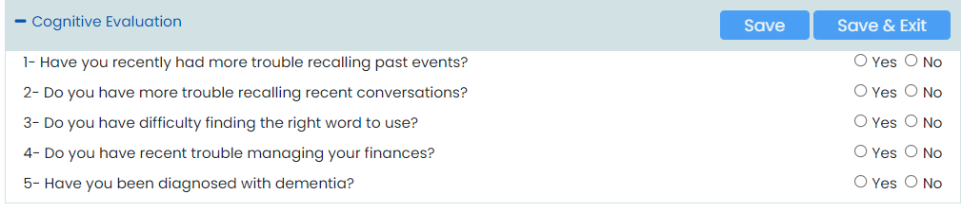

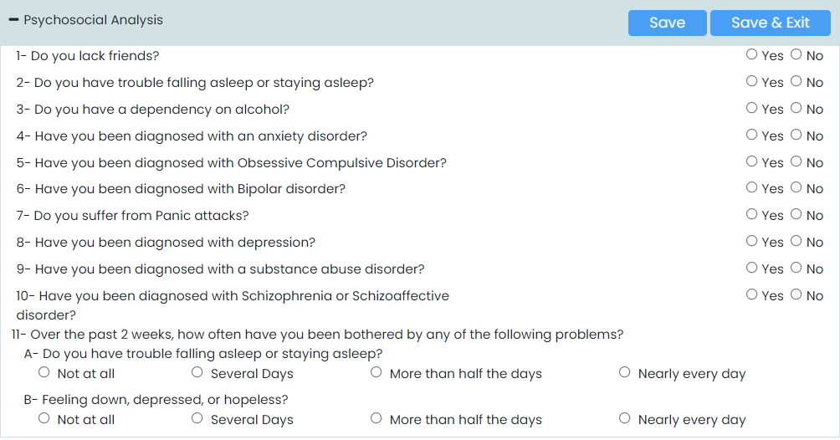

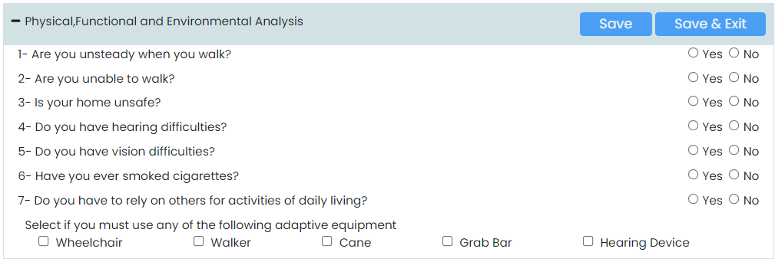

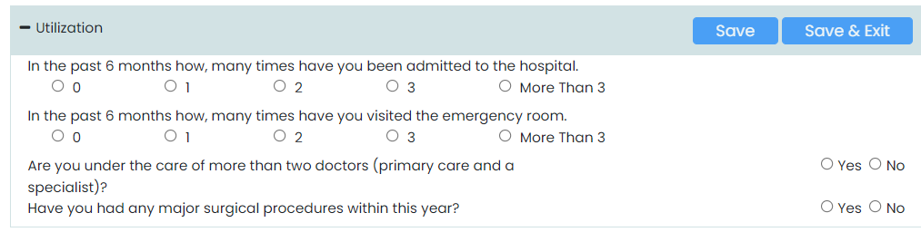

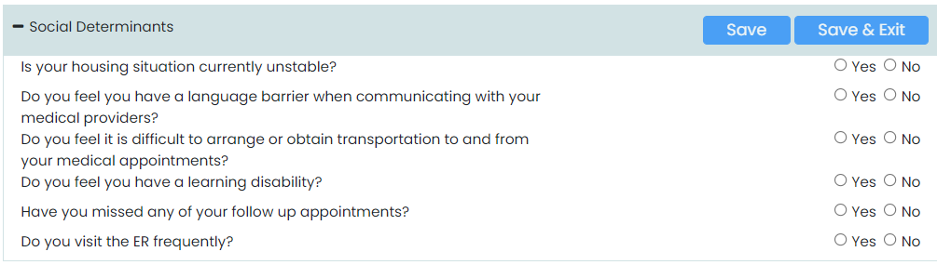

1. Some of the information forms whether the information is gathered according to patient’sient chronic condition include

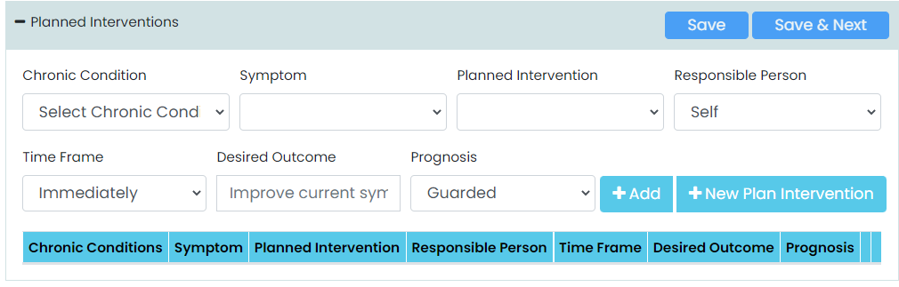

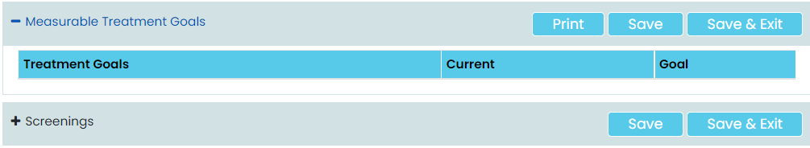

1. Some more information of medication, medical team, and testing.

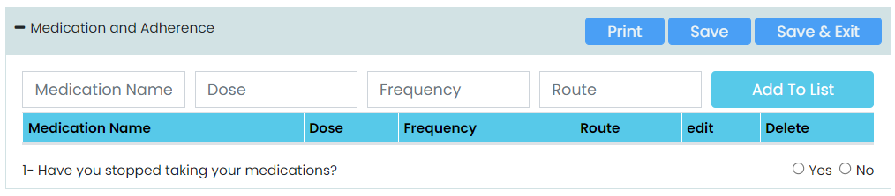

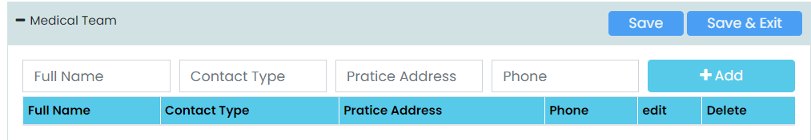

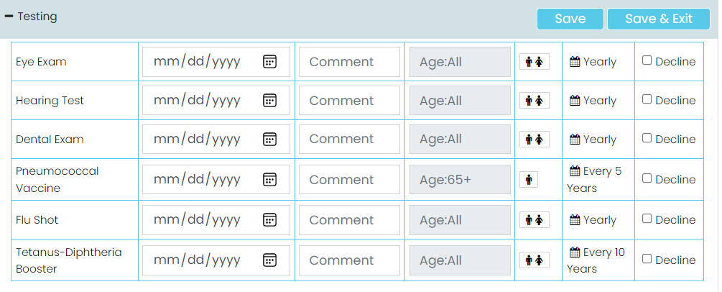

1. When the care plan is completed, Click on approve care plan action button to send the approval of the care plan to the provider.
2. If the care plan is directly under the provider then the provider approves the care plan at the current time.

## Tool Tip:

1. Cognitive Evaluation
2. Psychosocial Analysis
3. Physical, Functional, and Environmental Analysis
4. Medication and Adherence
5. Medical Team
6. Planned Interventions
7. Measurable Treatment Goals
8. Screening
9. Testing
10. Utilization
11. Social Determinants

## Database and SP’s:

1. Table:
2. Stored Procedure:

## ER- Diagram:

## Screenshot:

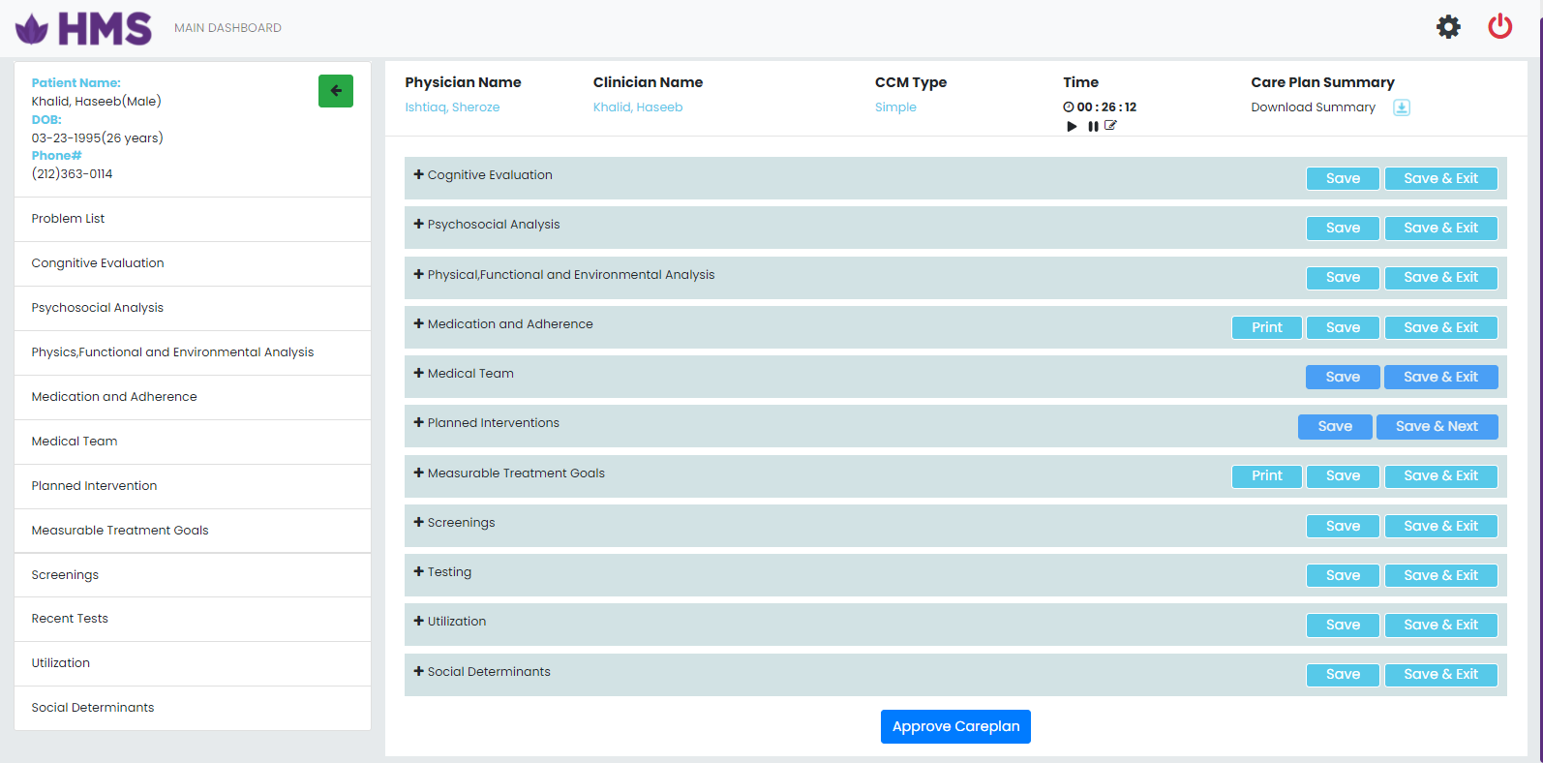

# HMS Monthly Review.

## Description:

The main purpose of HMS is to provide care to the patient. A monthly review is also a specially crafted document for aged patients that are not able to go to hospitals. Patients are easily directly consulted with the practice user from home. The care plan is run for the patient on a monthly basis if the patient first completes the care plan.

## User Story:

As a user, I want to start the monthly Review of the patient. Click on any patient in the patient dashboard and start the monthly review by clicking on the monthly review. A care plan is a specially crafted document for the patient to give services from home. The monthly review of the patient starts if the care plan of the patient is complete. The time period of the simple chronic patient is 20 minutes and 60 minutes for the complex. After the monthly review of the patient is complete then click on approve care plan action button. Users can download the monthly review summary. The timer is placed on the top of the form to start the care plan. The specially crafted document are some types of questions that are given in the tooltip.

## Business Rules:

1. The patient must have a minimum of two chronic conditions.
2. Select the chronic patient type simple or complex.
3. Start the monthly review of the patients and start the time.
4. Monthly review is start if care plan of patient is completed first.
5. When the monthly review is completed, click on the save and submit action button to save changes.
6. If the monthly review is not complete then click on the exit action button to leave this page.
7. All the information is save in the database.

## Tool Tip:

## Database and SP’s:

1. Table:
2. Stored Procedure:

## ER- Diagram:

## Screenshot:



# HMS Annual wellness.

## Description:

The main purpose of HMS is to provide care to the patient. The Annual wellness is also a specially crafted document for aged patients that are not able to go to hospitals. Patients are easily directly consulted with the practice user from home. The annual wellness is run for the patient on an annual basis if the patient first completes the care plan and monthly review.

## User Story:

As a user, I want to start the annual of the patient. Click on any patient in the patient dashboard and start the annual wellness by clicking on the annual wellness. Annual wellness is a specially crafted document for the patient to give services from home. The annual wellness of the patient starts if the care plan of the patient is complete. The time period of the simple chronic patient is 20 minutes and 60 minutes for the complex. After the annual wellness of the patient is complete then click on the save and submit action button. Users can also download the annual wellness summary. The specially crafted document are some types of questions that are given in the tooltip.

## Business Rules:

1. Start the Annual Wellness of the patients and start the time.
2. Annual wellness includes some questioner parts, tests reports, medical history, and analysis on patient’ chronic conditions.

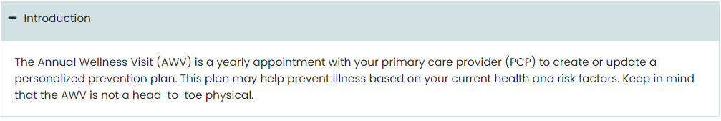

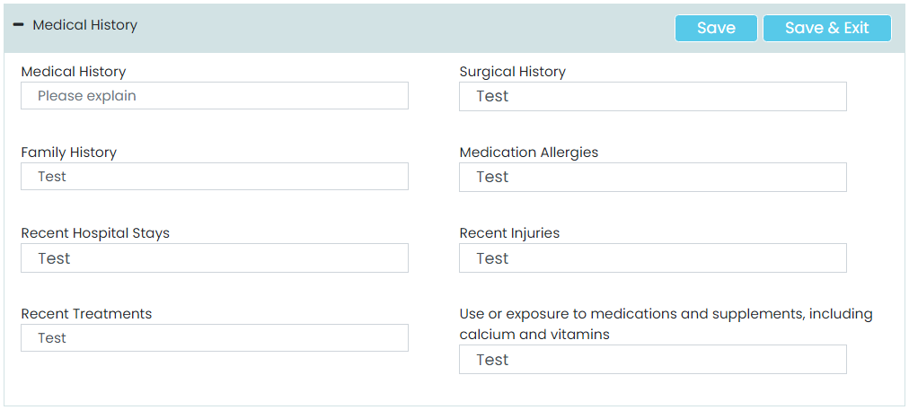

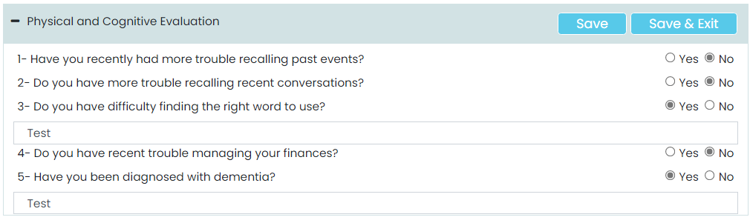

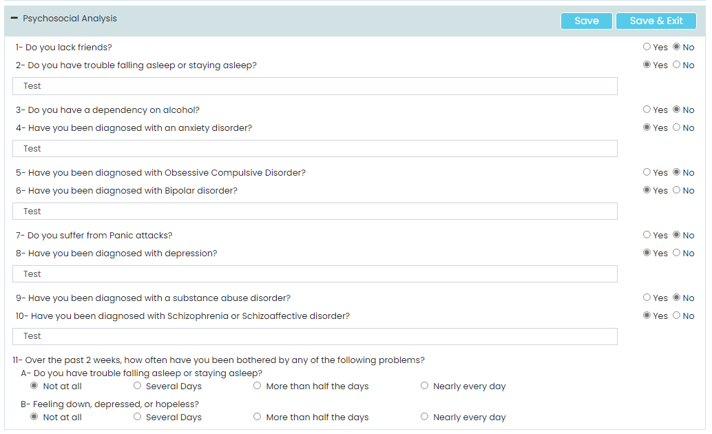

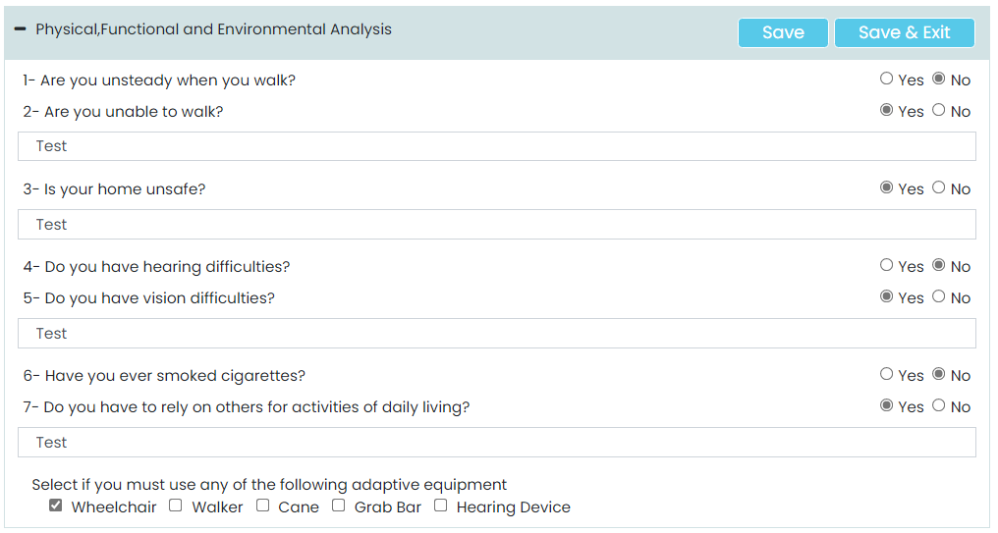

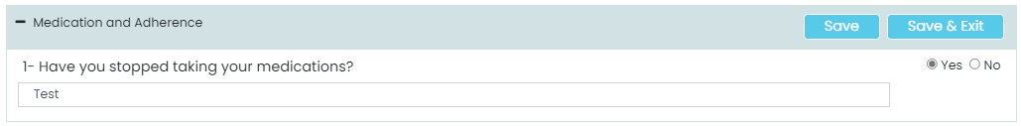

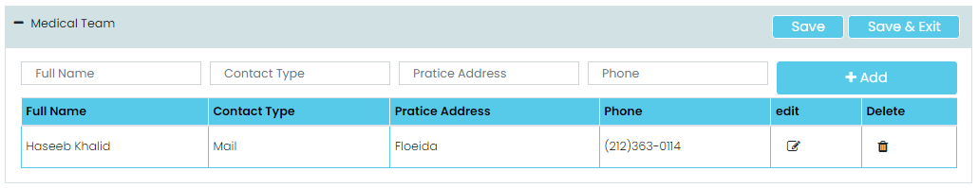

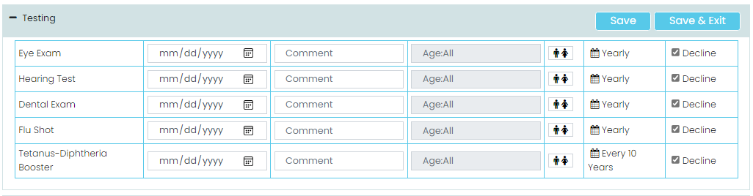

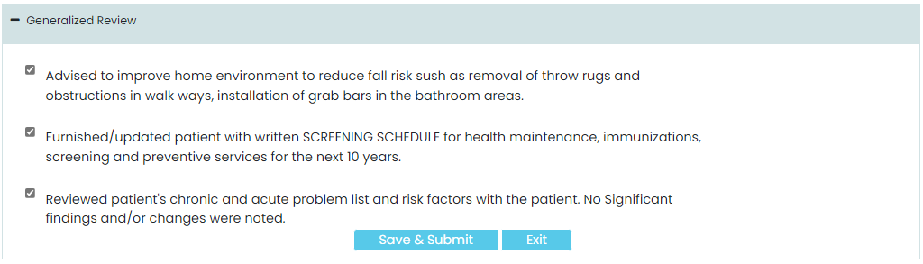

1. When the annual wellness is completed, click on the save and submit action button to save changes.
2. If the annual wellness is not complete then click on the exit action button to leave this page.
3. All the information is saved in the database.
4. Users also start advance care plans of patients from this section by simply clicking on Start Advance Care Planning.

## Tool Tip:

1. Medical History
2. Physical and Cognitive Evaluation
3. Psychosocial Analysis
4. Physical, Functional, and Environmental Analysis
5. Medication and Adherence
6. Medical team
7. Screening
8. Testing
9. Utilization
10. Social Determinants
11. Advance Care plan
12. Generalizes Review

## Database and SP’s:

1. Table:
2. Stored Procedure:

## ER- Diagram:

## Screenshot:

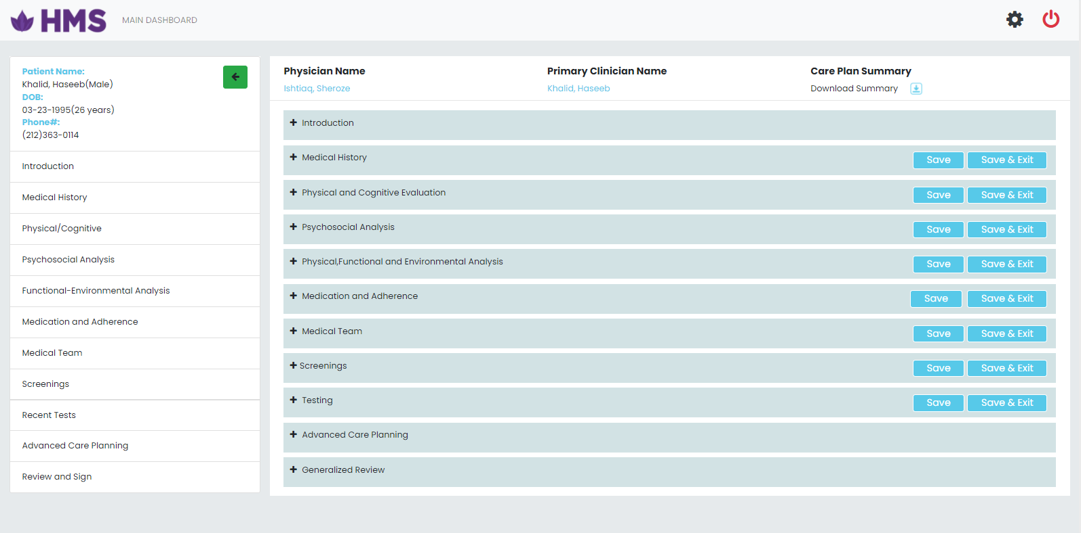

# HMS Advance CarePlan.

## Description:

## User Story:

## Business Rules:

## Tool Tip:

## Database and SP’s:

1. Table:
2. Stored Procedure:

## ER- Diagram:

## Screenshot:



# HMS CarePlan Communication Preferences

## Description:

Communication preferences are a way to communicate how we received and provide information between the user and the patient.

## User Story:

In the HMS care plan how the system user can communicate with the patient. In communication preferences, users enter the time preferred and communication preferences information gathered from the patient.

## Business Rules:

1. As a user, I want to give time to patients for the consult.
2. Patients provide the information given on this page.
3. Click on the save action button to assign a time to the patient.

## Tool Tip:

1. Enter time preferred
2. Enter communication preferences

## Database and SP’s:

1. Table:
2. Stored Procedure:

## ER- Diagram:

## Screenshot:

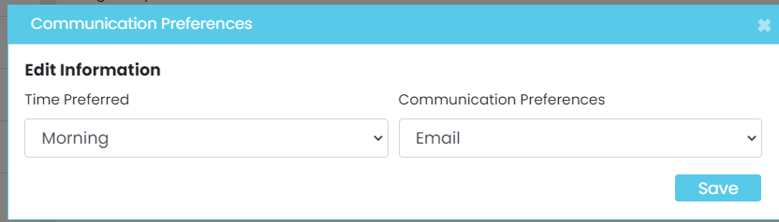

# HMS Patient Time Logs

## Description:

HMS provides a time log for both patient and user to chronologically record the detailed activity within a time stamp between the user of the system and the patient.

## User Story:

As a user I want to see the report of a patient time log, the date range is entered in the given form to see the time log with (call date), (call time), (description) of the care plan questioner, (created by) the user name who start the care plan of the patient, and (Elapsed time). Users easily download the report of patient time logs by clicking on the action button with an icon placed inside it placed at the top of the form.

## Business Rules:

1. As a user, I want to give time to patients for the consult.
2. Patients provide the information given on this page.
3. Click on the save action button to assign a time to the patient.

## Tool Tip:

Enter date range from date to date.

## Database and SP’s:

1. Table:
2. Stored Procedure:

## ER- Diagram:

## Screenshot:

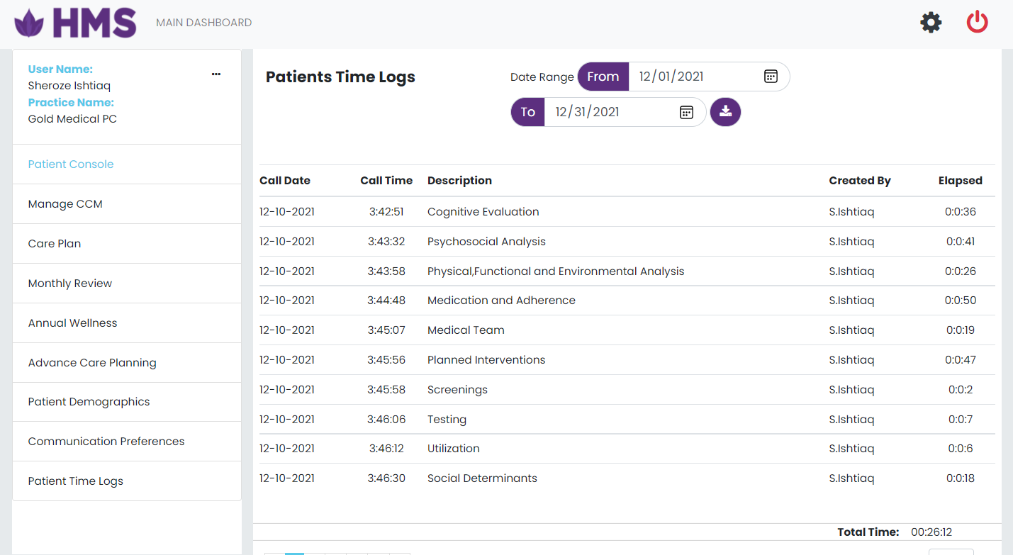

# HMS Manage Staff

## Description:

1. The Staff is an important part of HMS. The user/Provider will add staff (provider/clinician) from the Manage staff page.

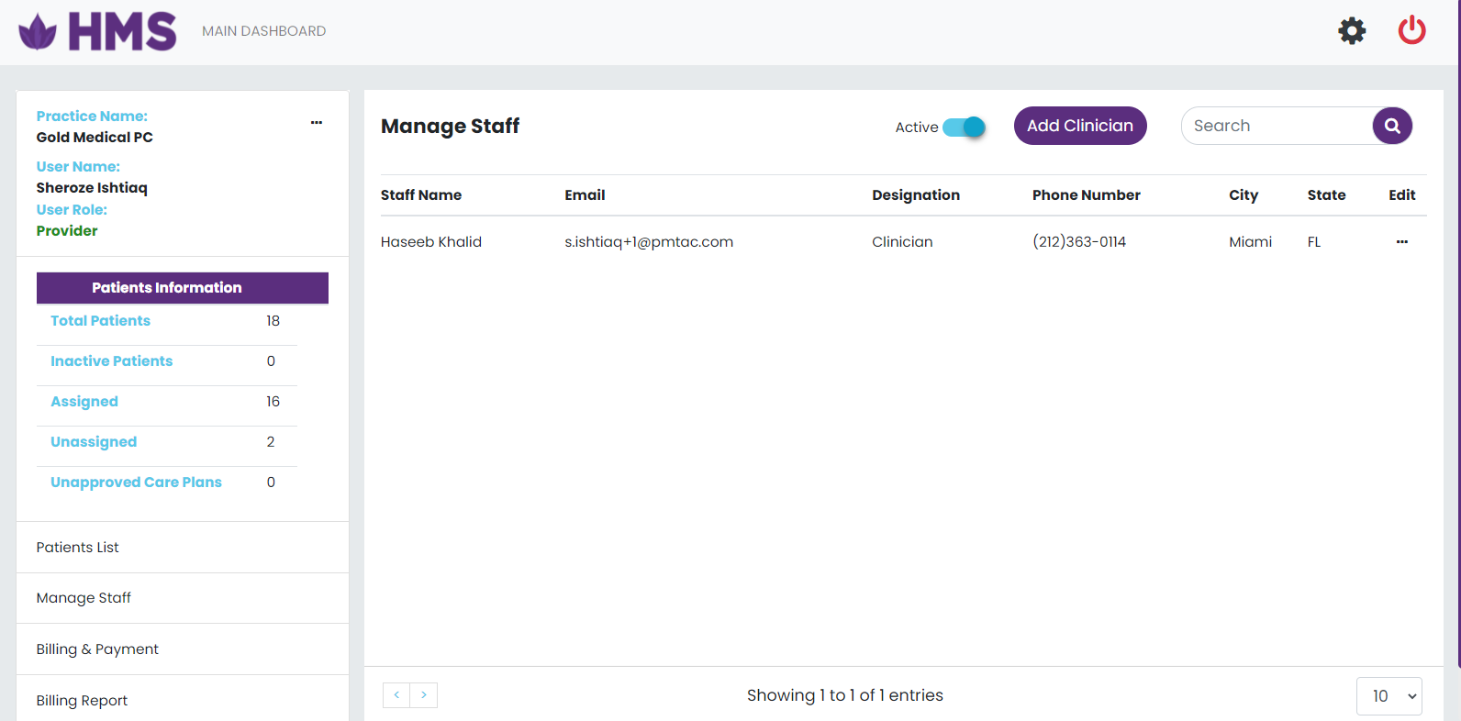

1. The user will be able to perform a crud operation to add and update clinicians.
2. The staff form view is displayed popup when clicking on add Staff button placed at the top of the patient dashboard.

## User Story:

1. The staff list view is displayed according to the user.
2. Information of total patients is displayed in the patient dashboard.
3. Footer of the list view of the dashboard show pagination, total entries, and the drop-down option where shows rows according to the selected number.
4. The header of the list view shows the active check button, add clinician, and filter to search staff name.
5. The Staff form view is displayed popup when clicking on add patient button placed at the top of the patient dashboard.
6. Click on the Active checkbox to see active and inactive staff information.
7. Click on Edit to update patient information.
8. Click on Edit to active and inactive patient.

## Business Rules:

1. On the Add Staff page set placeholder messages and button text according to the selected culture.
2. Click on add Staff button a popup form will be open.
3. For Enroll new Staff in HMS, enter all the Staff information.
4. The action button (Save) is placed at the bottom of the page.
5. If a Staff is not added successfully, the system will show the validation message.
6. All information in the form is mandatory except the middle initial (M.I).
7. If add operation successfully then redirect to the Staff dashboard.
8. The information of the inserted Staff is shown on the Staff page.

## Tool Tip:

1. User Information
2. First Name
3. M.I
4. Last Name
5. User Name
6. Password
7. Confirm Password
8. Email Address
9. Phone Number
10. Select Role
11. City
12. Select State
13. Zip Code

## Database and SP’s:

1. Table:
2. Stored Procedure:

## ER- Diagram:

## Screenshot:

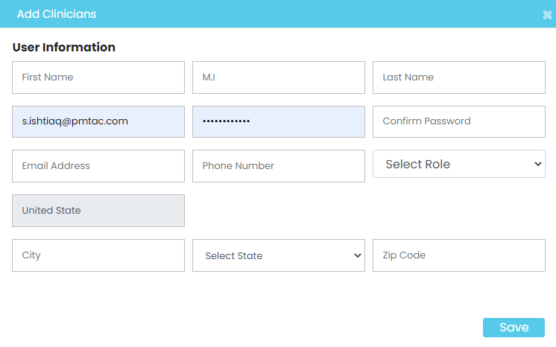

# HMS Update Staff Information

## Description:

1. The Staff is an important part of HMS. The user/Provider will add staff (provider/clinician) from the Manage staff page.



1. The user will be able to perform a crud operation to add and update clinicians.
2. The staff form view is displayed popup when clicking on add Staff button placed at the top of the patient dashboard.

## User Story:

1. After login directly redirects to the Patient dashboard where all the operations are managed by the different roles shows only permission areas based on the group.
2. Information of total staff is displayed in the staff dashboard.
3. Footer of the list view of the dashboard show pagination, total entries, and the drop-down option where shows rows according to the selected number.
4. The header of the list view shows the active check button, add clinicion, and filter to search patient name.
5. The updated clinician form view is displayed popup when clicking on edit placed at the manage staff table on patient dashboard.
6. Click on the Active checkbox to see active and inactive staff information.
7. The search option is shown with the add clinician button.
8. Click on Edit to update staff information.
9. Click on Edit to active and inactive staff.

## Business Rules:

1. To update Staff information in HMS, enter the staff information that is required to update.
2. The action button (Edit) is placed at the last column of the manage staff table of the page.
3. All information is gathered from the patient and click on the update button.
4. Update operation successfully then redirect to the manage staff dashboard.
5. The information of updated staff information is shown on the manage staff table.

## Tool Tip:

## Patient Demographics

1. First Name
2. Middle initial
3. Last name
4. Username
5. Email
6. Phone number
7. City
8. Select state
9. Zip Code

## Database and SP’s:

1. Table:
2. Stored Procedure:

## ER- Diagram:

## Screenshot:



# HMS Billing & Payment

## Description:

Billing is the process of invoicing customers for goods and services. In this system owner user of the practice is paying his monthly cost of practice that is registered in the HMS.

## User Story:

As a user, I want to pay my monthly billing to the owner of the system by clicking on the patient dashboard Payment and Billing option placed at the side of the dashboard. A popup form is open on the screen. Where the user enters his own Card information and billing information, and save button is placed at the bottom of the form, to save the information of the billing and payment report.

## Business Rules:

Users easily bill and payment by clicking on the Save button.

The information is successfully saved if the user enters his all information.

If failed then the system will show the validation message plz enter all the fields properly in the form.

## Tool Tip:

1. Card Information
2. Cardholder Name
3. Card number
4. Billing Information
5. Address1
6. Address2
7. City
8. State
9. Zip Code
10. Phone
11. Email

## Database and SP’s:

1. Table:
2. Stored Procedure:

## ER- Diagram:

## Screenshot:

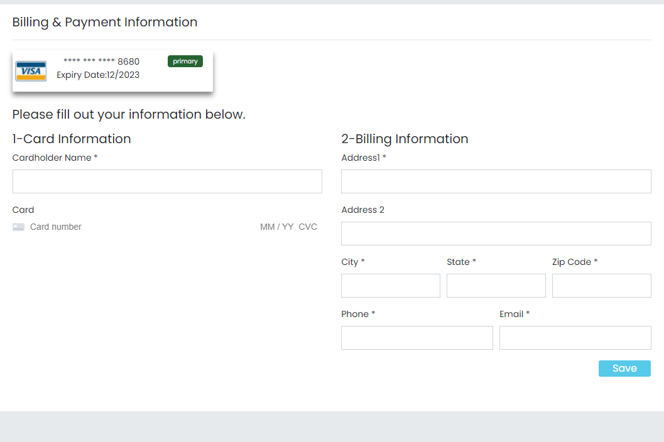

# HMS Billing Report.

## Description:

The report is an important aspect of any system. That presents information in an organized format for a specific purpose. As a provider, I want to see the billing report of practice from this date to this date.

## User Story:

1. Users will easily print billing reports by giving the following information.
   1. From Date
   2. To Date
2. The print action button is placed at the bottom of the print billing form.

## Business Rules:

1. You can access billing reports easily by giving the following information
2. Enter From Date
3. Enter To Date
4. Click on the action button print.
5. The billing report is printed on the excel sheet.

## Tool Tip:

1. From Date
2. To date

## Database and SP’s:

1. Table:
2. Stored Procedure:

## ER- Diagram:

## Screenshot:

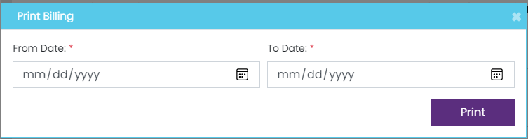

# HMS Approve CarePlan.

## Description:

The main purpose of HMS is to provide care to the patient. A care plan is a specially crafted document for aged patients that are not able to go to hospitals. Patients are easily directly consulted with the practice user from home. The care plan is run for the patient at a single time in the life. Changes are occurring in the care plan according to the time of period if required.

## User Story:

The approval of the care plan report and pending report is shown in the patient dashboard by clicking on approve care plan. Approve and pending action button is placed at the top of the approved care plan list. , and filter to search by patient name.

## Business Rules:

1. Click on the pending button to see the pending care plan report.
2. Click on approve button to see the approved care plan report.

## Tool Tip:

Pending and Approve Button

## Database and SP’s:

1. Table:
2. Stored Procedure:

## ER- Diagram:

## Screenshot:

